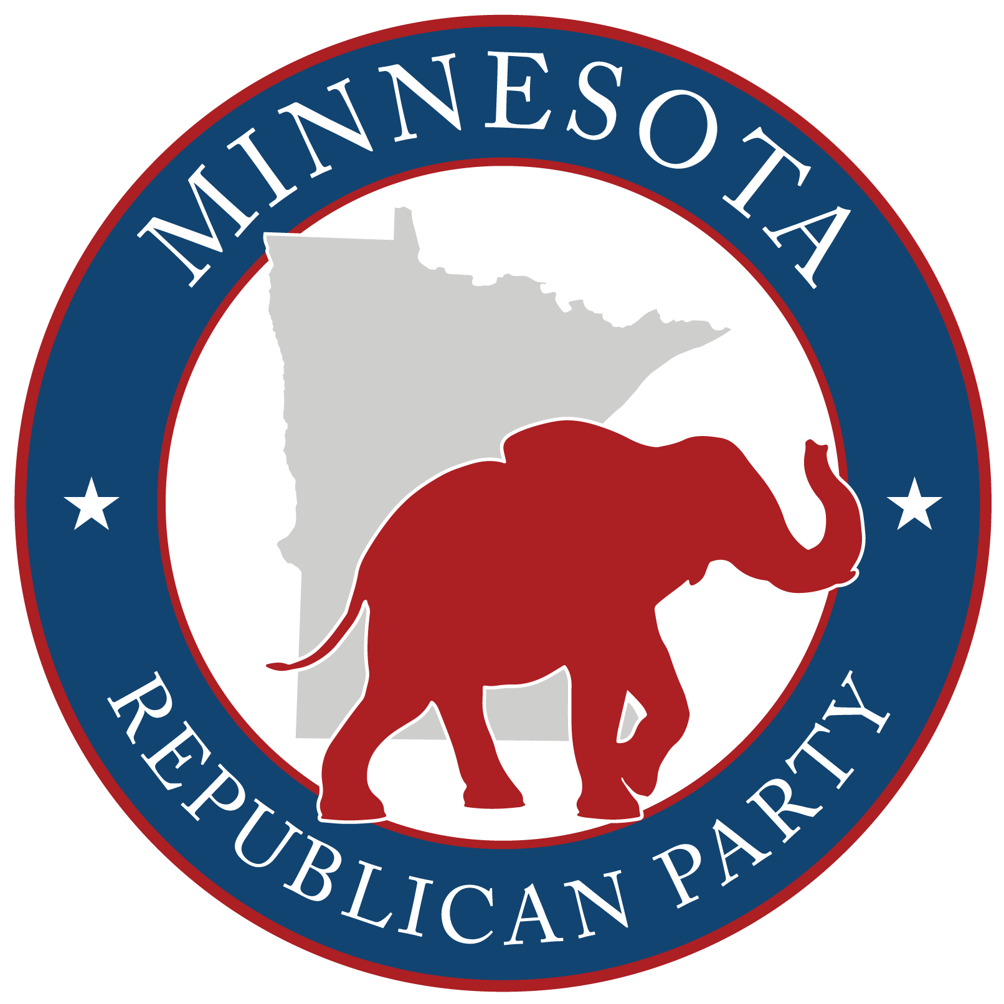

Non-Attendee Participation Form

Itasca County Republicans – [Precinct ID / Precinct Name]
Caucus Date/Time: February 3rd 2026, 7:00 p.m.
Submit to: Chair@itascacountygop.com • 218-256-2115
Deadline: JANUARY 27,2026 / 7:00PM
Participant Information
Full Name: __________________________________________________________________________________________________________
Precinct Address: ___________________________________________________________________________________________________
City / ZIP: ___________________________________________________________________________________________________________
Phone: __________________________ Email: __________________________
I will be 18 years old by the next General Election: ☐ Yes ☐ No
Eligibility & Party Agreement (check all that apply)
☐ I reside in this precinct.
☐ I am eligible to vote in the next General Election.
☐ I generally agree with the principles of the party and intend to support its candidates.
Office or Position Sought (check all that apply)
☐ Precinct Officer (specify): ☐ Chair ☐ Vice Chair ☐ Secretary ☐ Other: ____________________
☐ BPOU Convention: ☐ Delegate ☐ Alternate

Candidate Statement (Maximum 150 words per office sought)
____________________________________________________________________________________________________________________________________
____________________________________________________________________________________________________________________________________
____________________________________________________________________________________________________________________________________
____________________________________________________________________________________________________________________________________
____________________________________________________________________________________________________________________________________
___________________________________________________________________________________________________________________________________
Participant Certification
I certify that the information provided above is true and correct and that I meet all eligibility requirements for participation in the precinct caucus as a non-attendee.
Participant Signature: _________________________________ Date: ____________________________________________________
BPOU Chair Verification
I certify that this Non-Attendee Participation Form was submitted in accordance with party rules and deadlines, and that the eligibility of the individual named above has been reviewed and verified.
BPOU Chair Name (print): _________________________________________________
BPOU Chair Signature: ___________________________________ Date: _________________________________________________

*Please note that each precinct must vote to accept absentee participation in advance of putting names into nomination.

